**Apartment Management Website Project Report**

I have two point of views to my website

**1)Normal User Point of View**

It is in test level and not finished completely. Normal users can just see contents of tables. They can not add, edit and delete contents. They can see above.

This is full-screen of Announcements Tab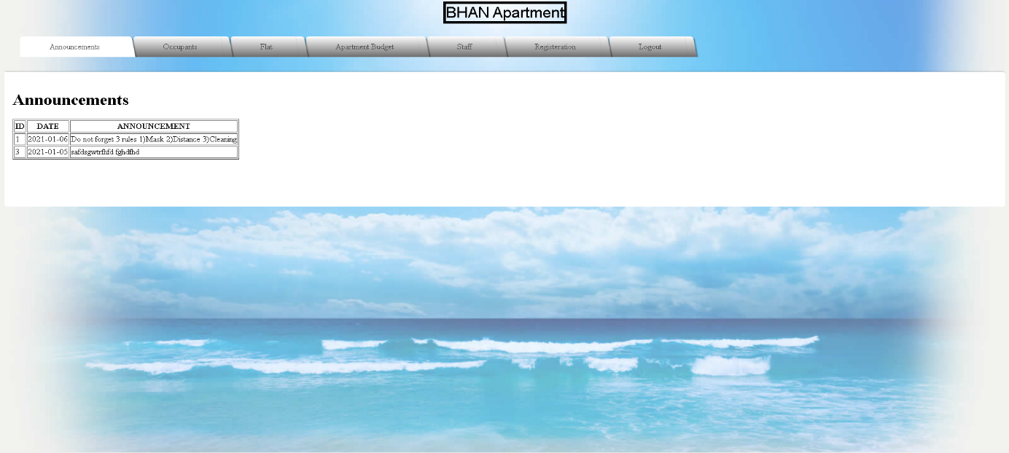

This is a smaller screen of Announcements Tab

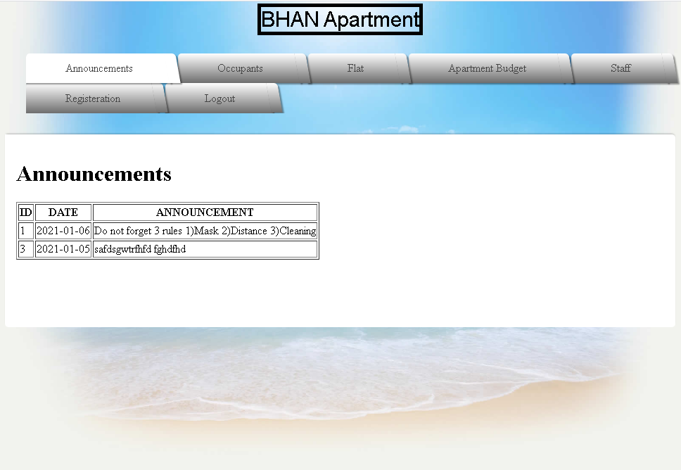

This is full-screen of Occupants Tab

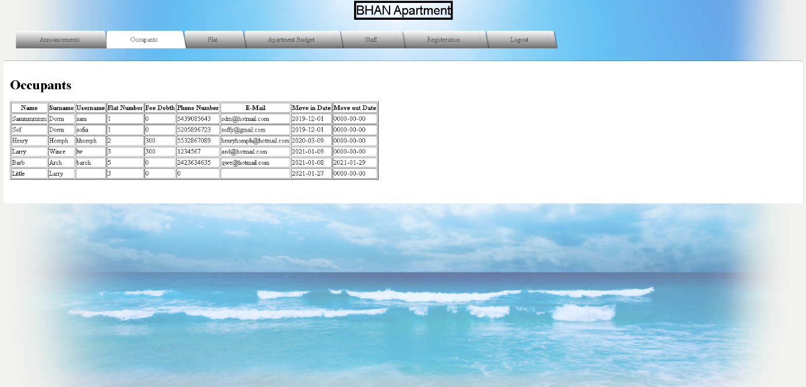

This is a smaller screen of Occupants Tab

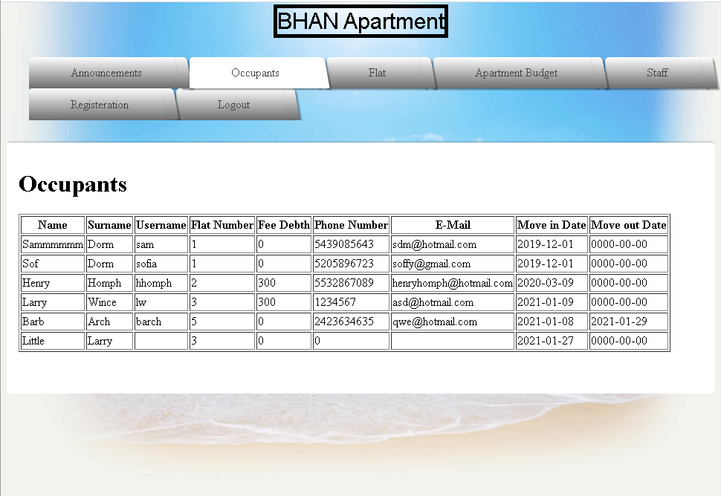

This is full-screen of Flat Tab and content of Flat A button

Tab

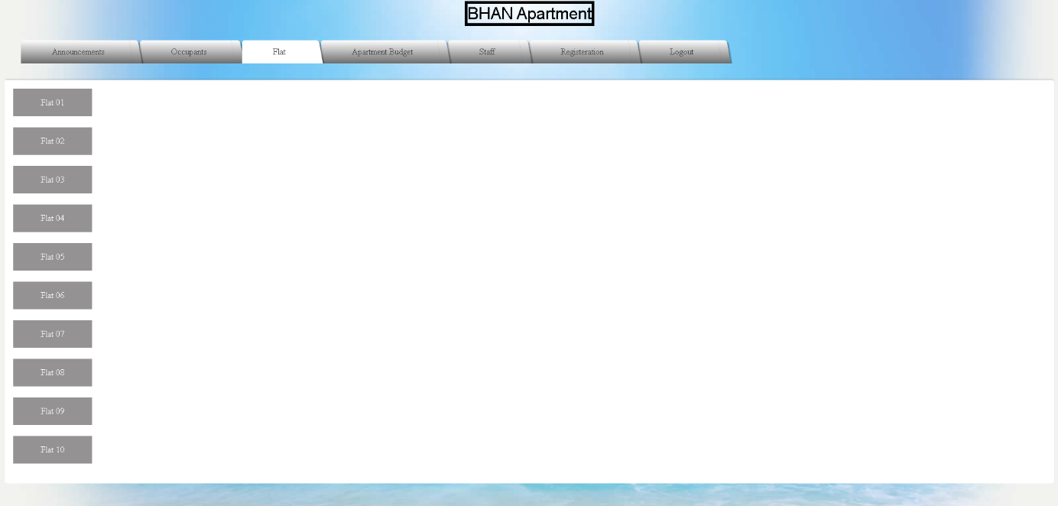

Inside of Button

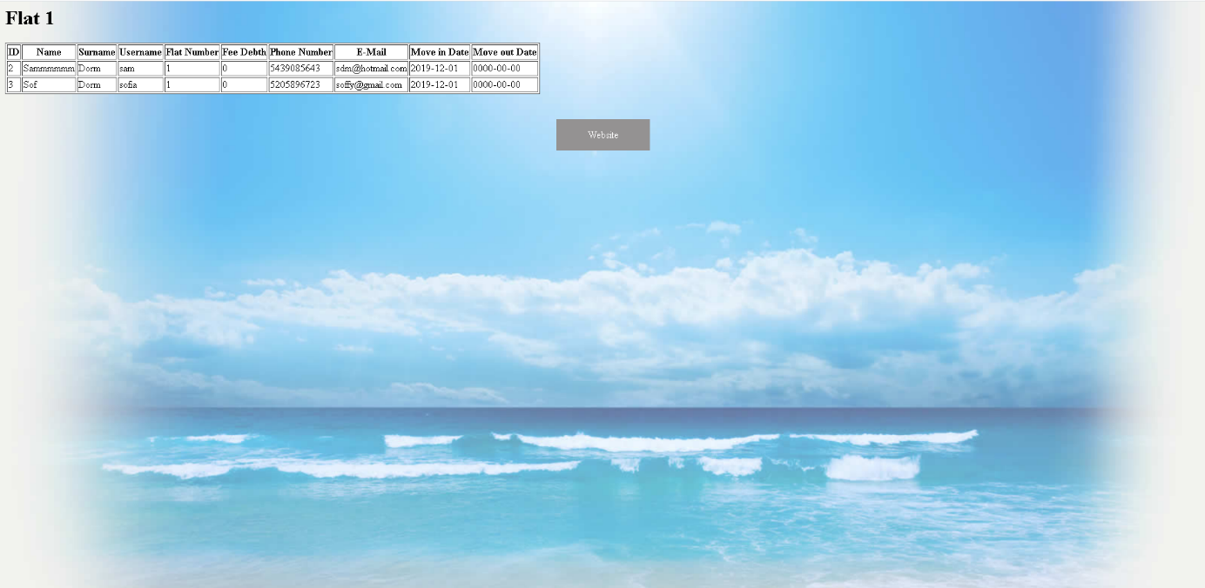

This is a smaller screen of Flat Tab and content of Flat A button

Tab

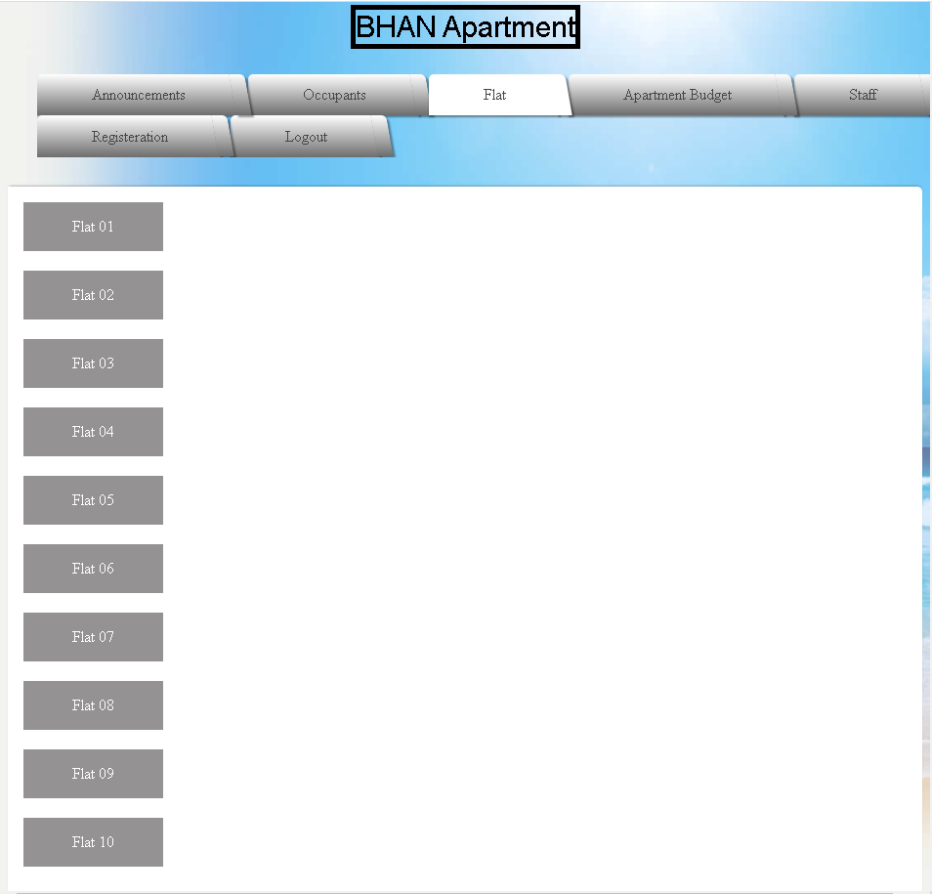

Inside of Button

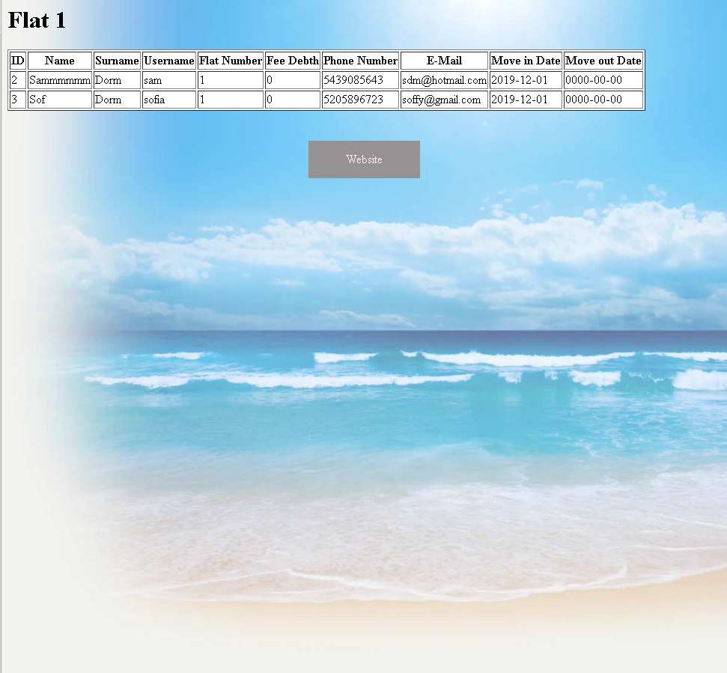

This is full-screen of Apartment Budget Tab

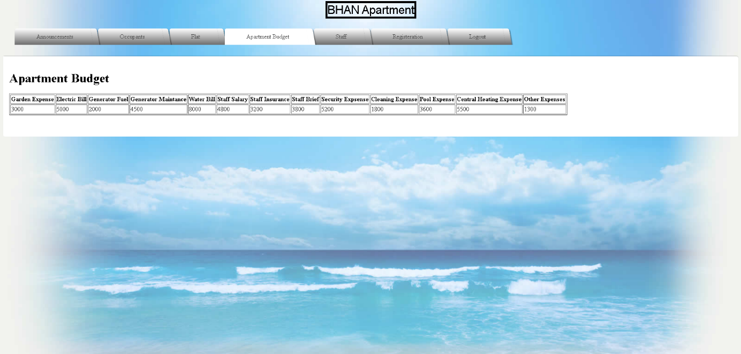

This is a smaller screen of Apartment Budget Tab

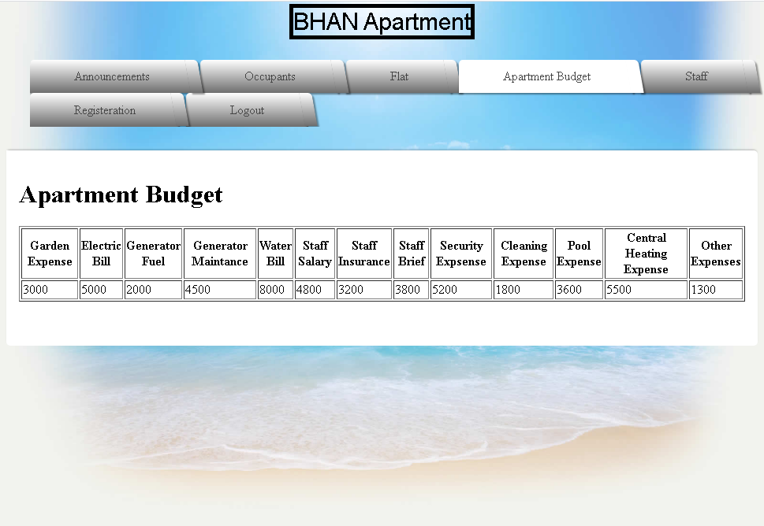

This is full-screen of Staff Tab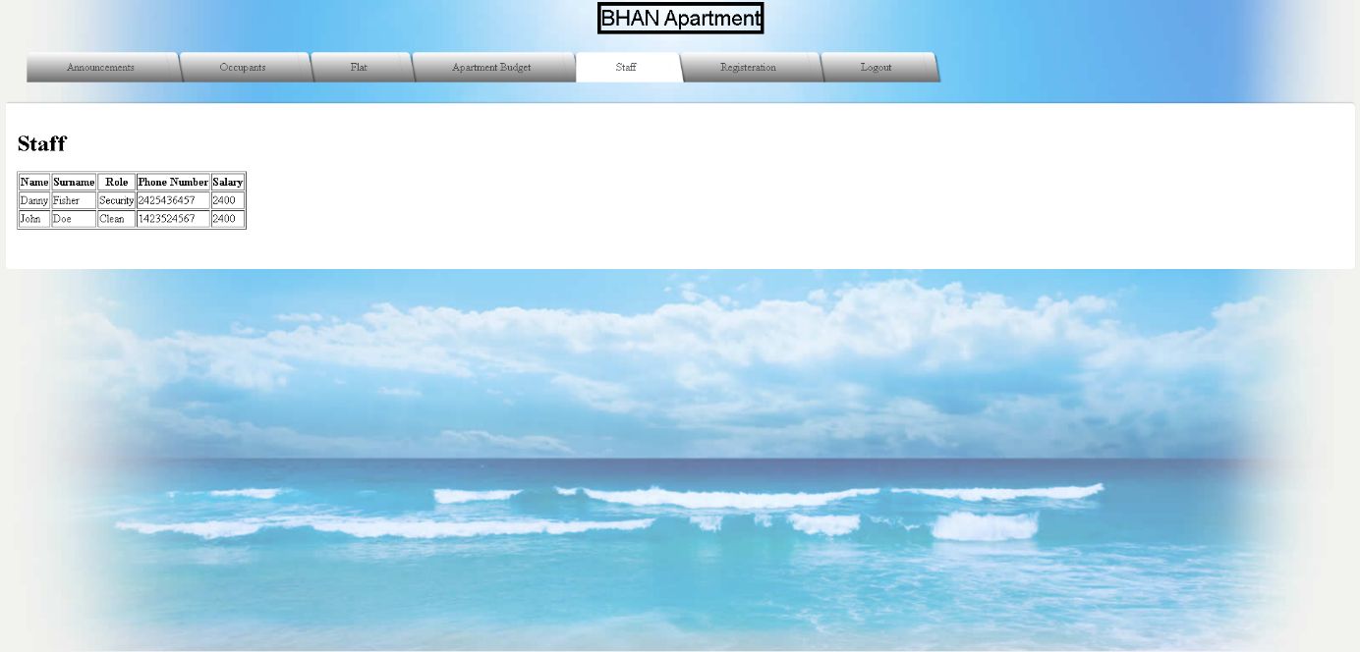

This is a smaller screen of Staff Tab

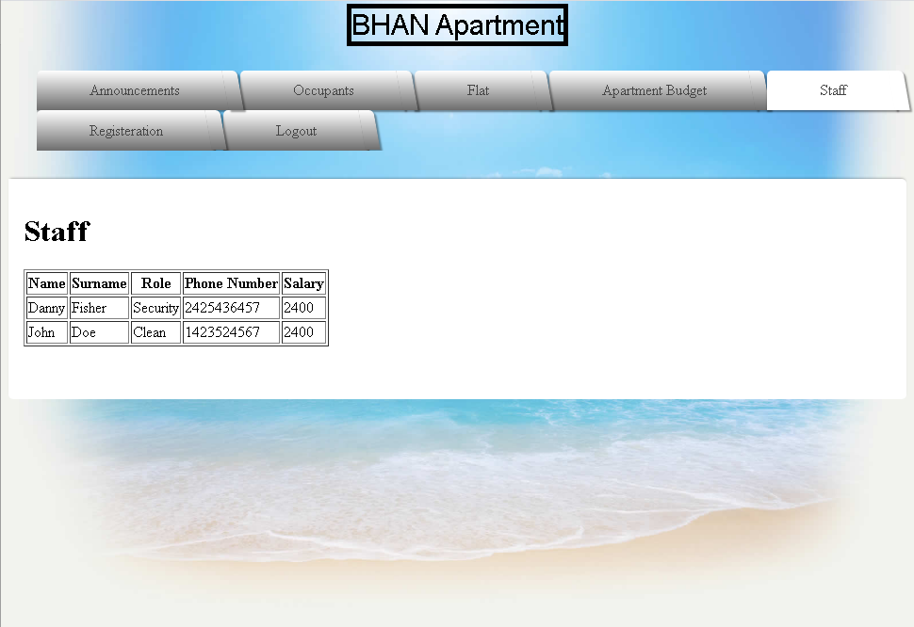

This is full-screen of Registeration Tab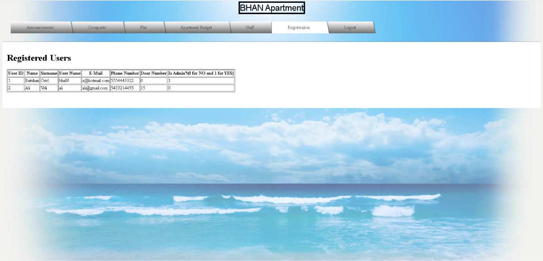

This is a smaller screen of Registeration Tab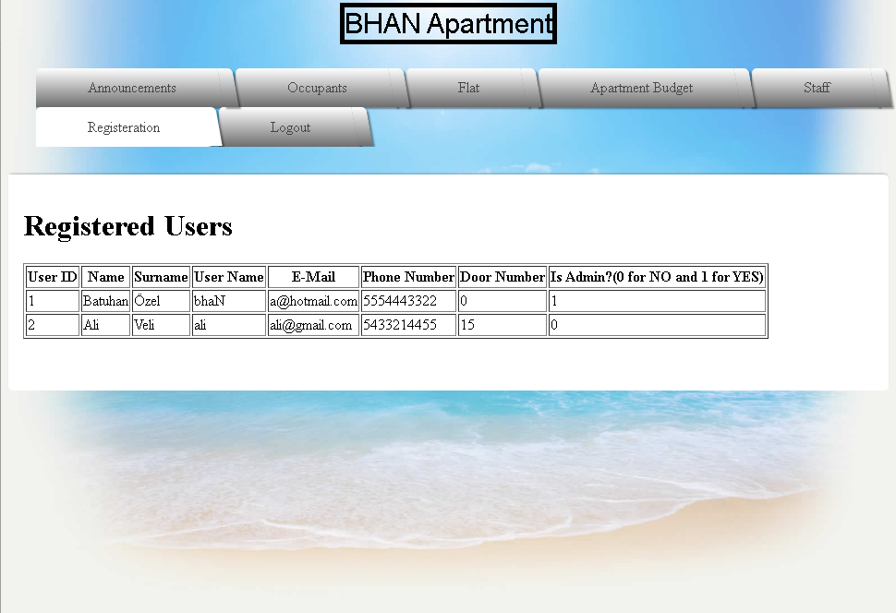

This is full-screen of Logout Tab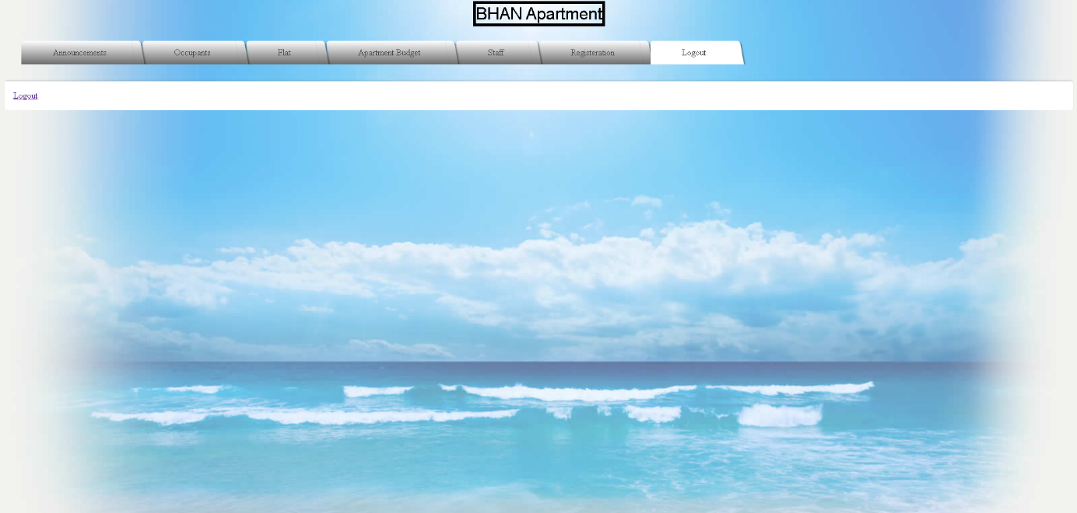

This is a smaller screen of Logout Tab

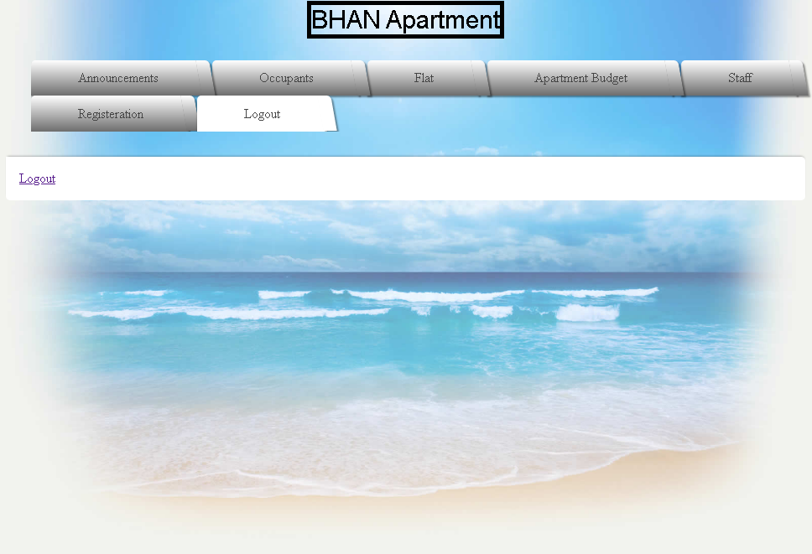

When weclick logout, login screen occurs.

**1)Admin Point of View**

Admin can see contents of tables and add, edit, delete their properties. They can see above.

Login Screen

Full-Screen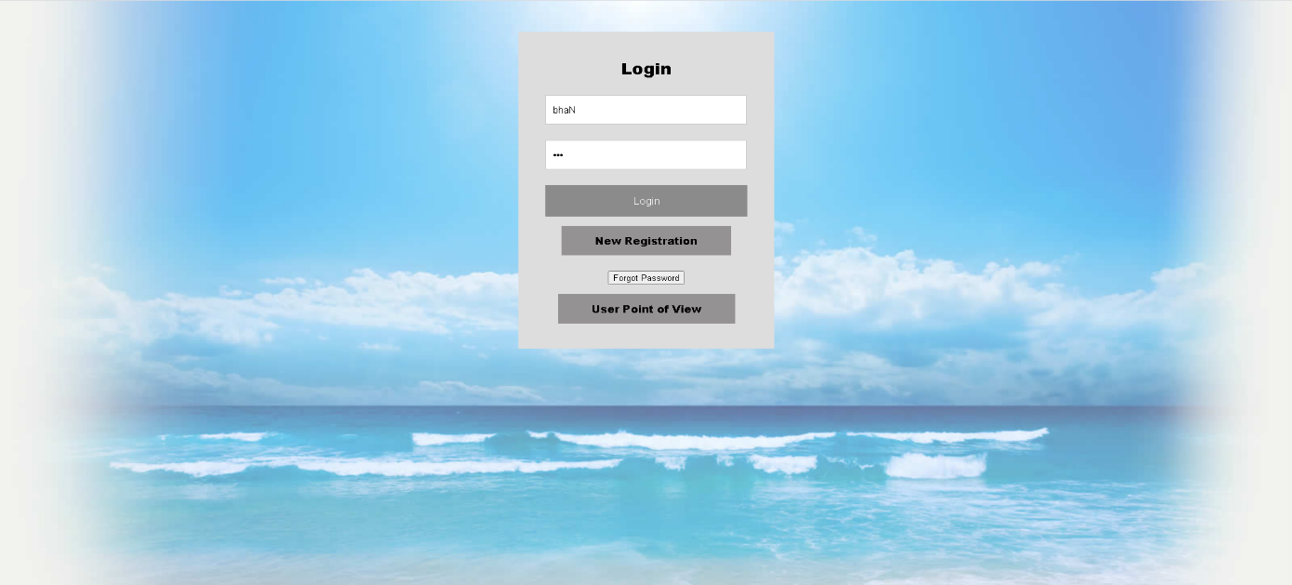

Small Screen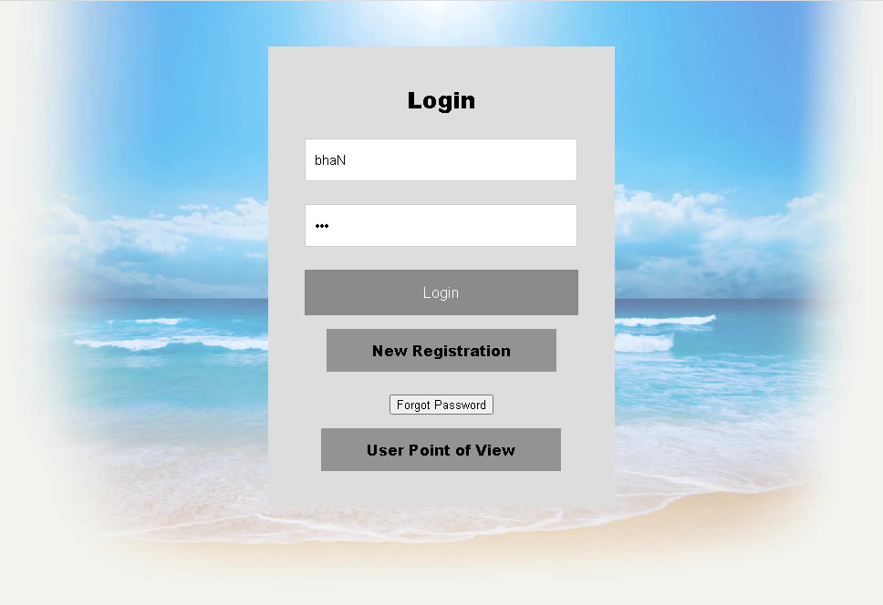

After Login there is a Dashboard Screen

When we click Website, our main page occurs.

Full-screen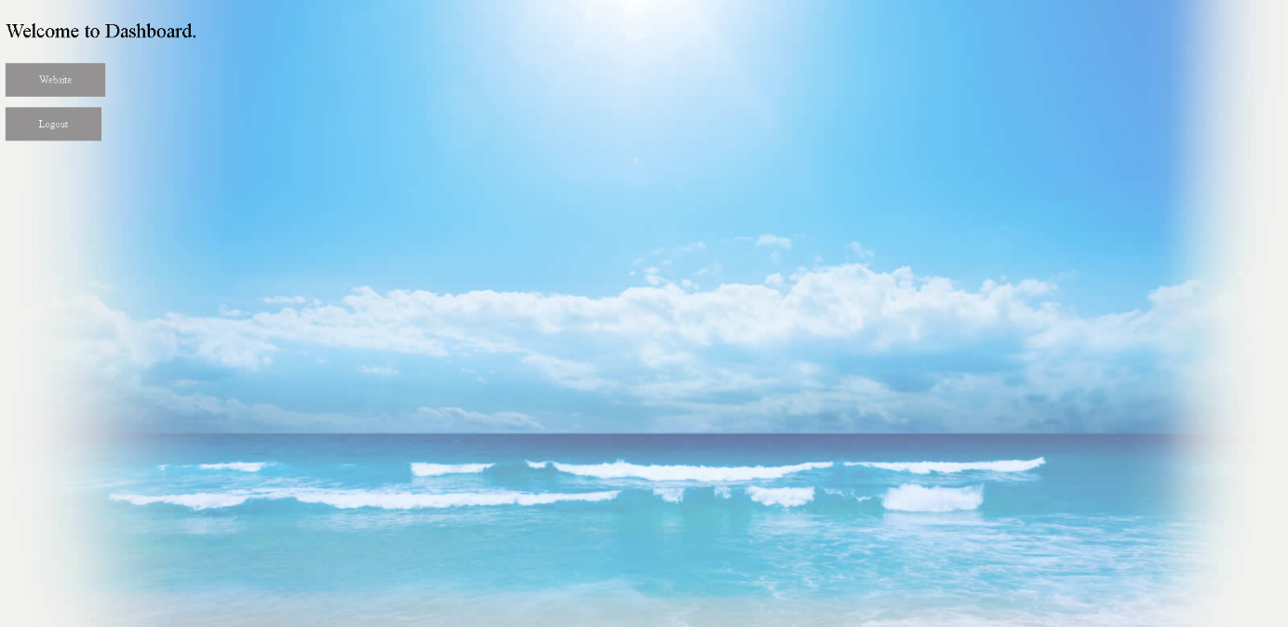

Small Screen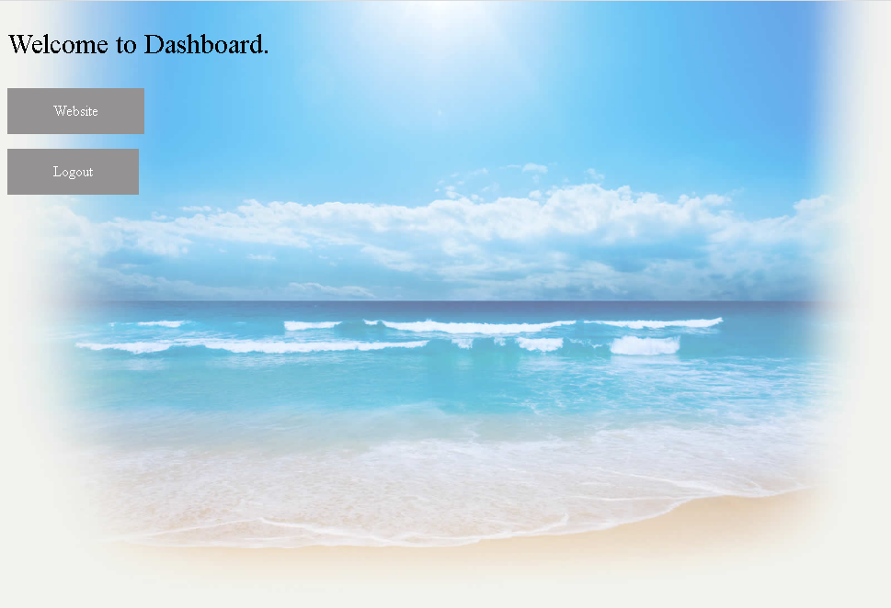

Register Screen

Full-Screen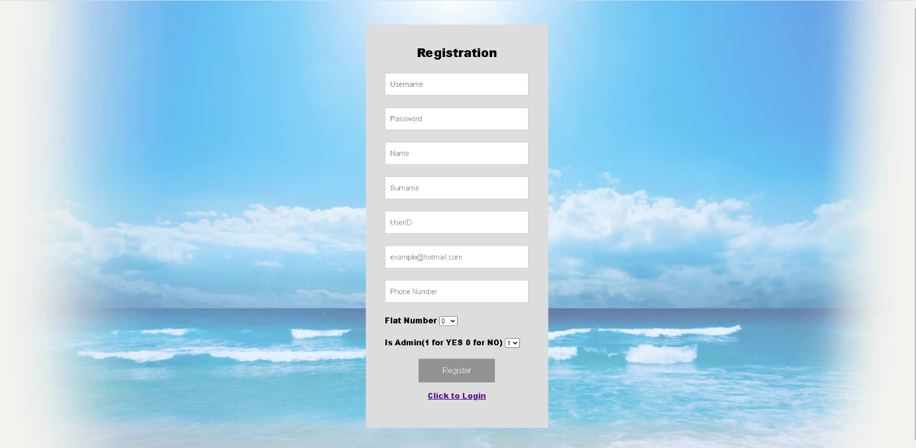

Small Screen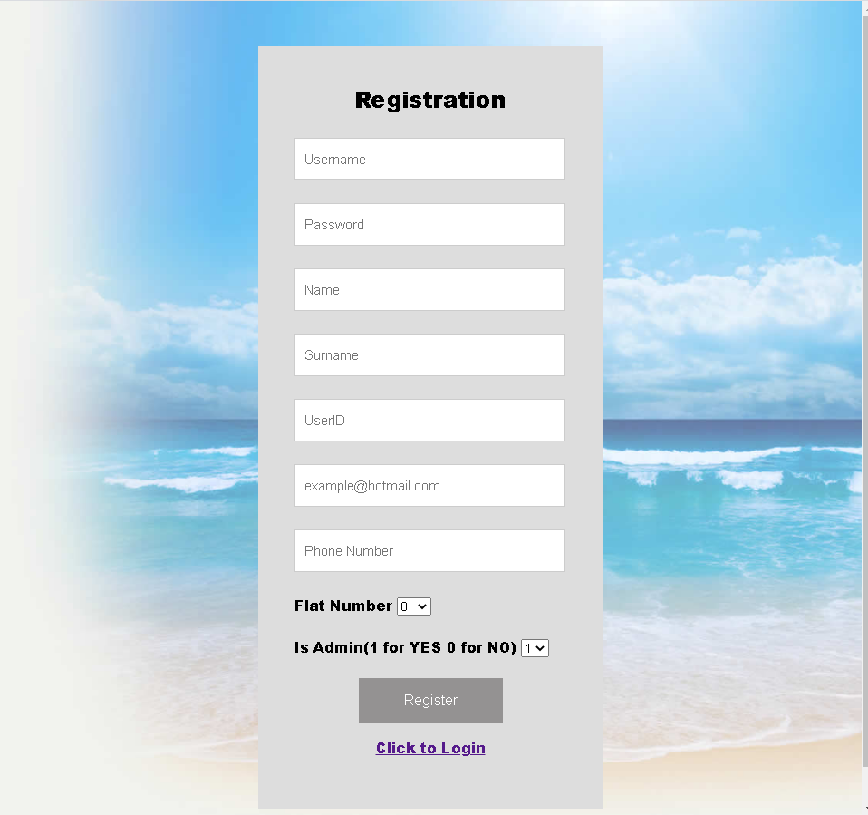

This is Announcements Tab

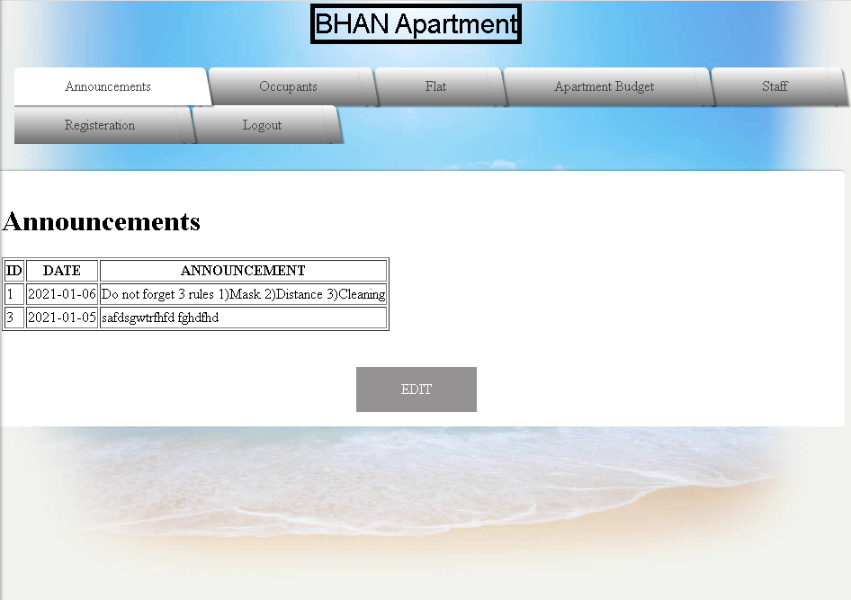

When we click EDIT , this screen occurs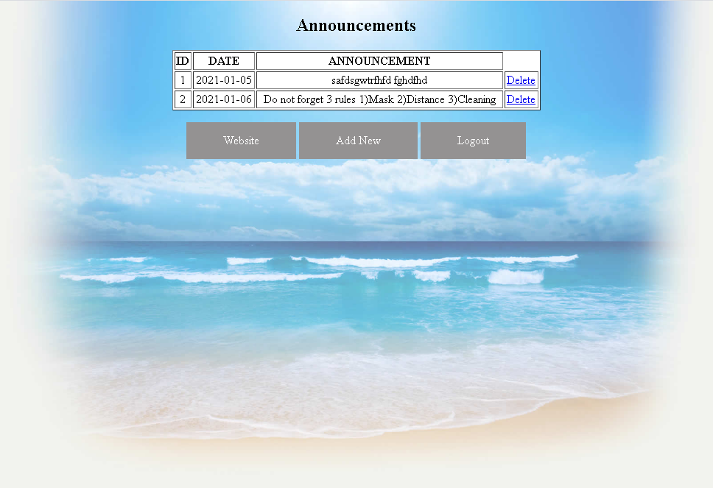

This is Occupants Tab

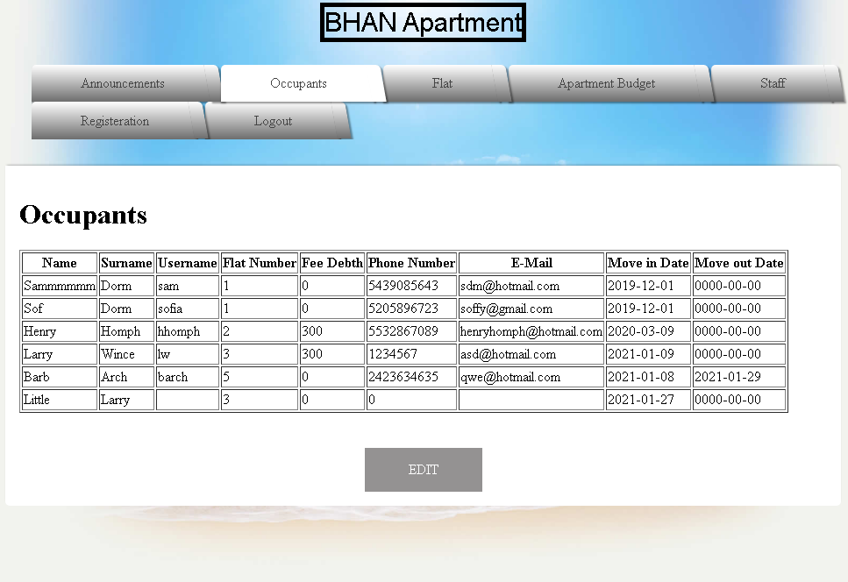

When we click EDIT , this screen occurs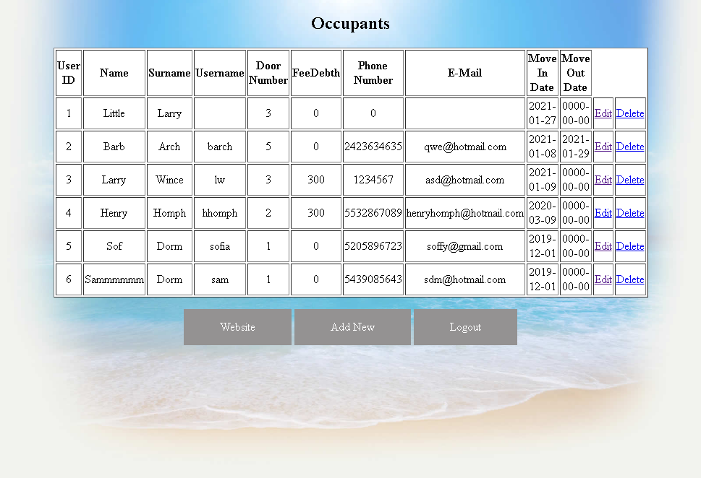

This is Flat Tab and content of Flat A button

Tab



Inside of Button



This is Apartment Budget Tab

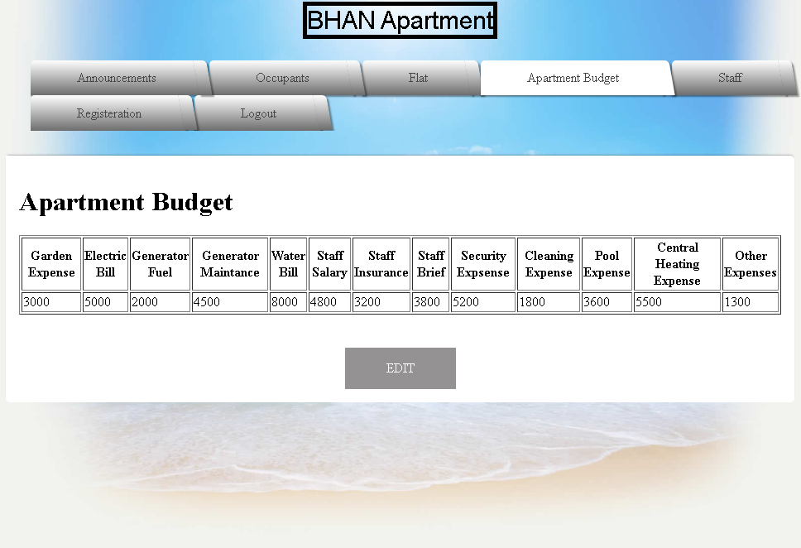

When we click EDIT , this screen occurs

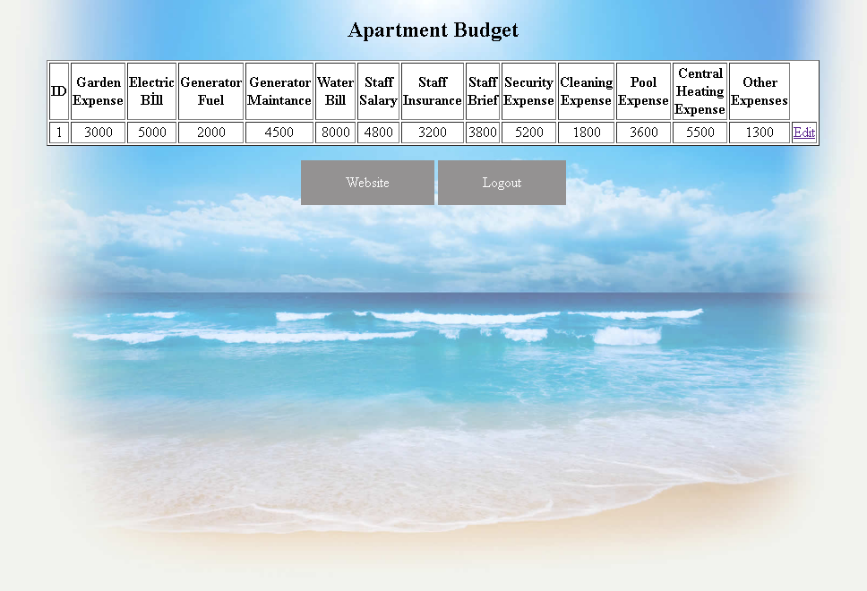

This is Staff Tab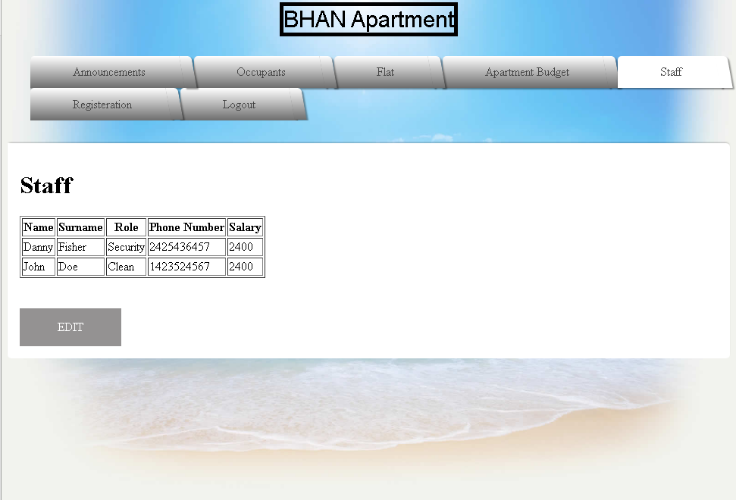

When we click edit, this screen occurs

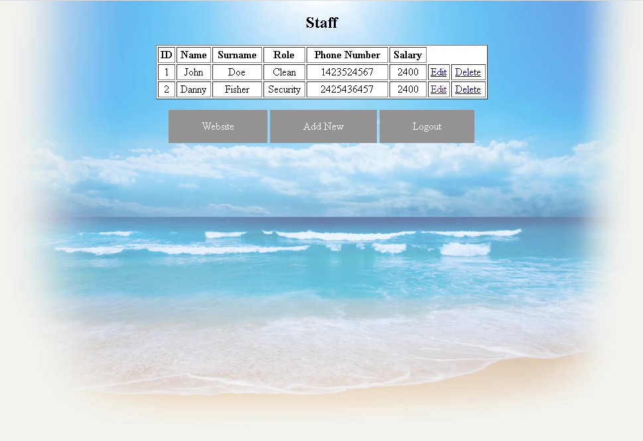

This is Registeration Tab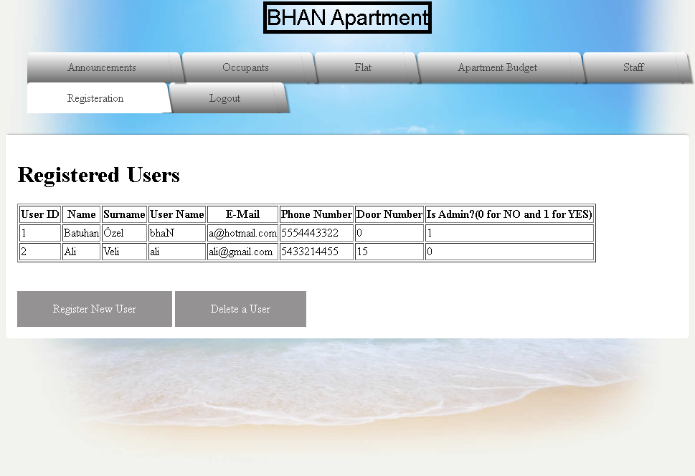

When we click Register New User, Register Screen Occurs.

When we click Delete, this screen occurs

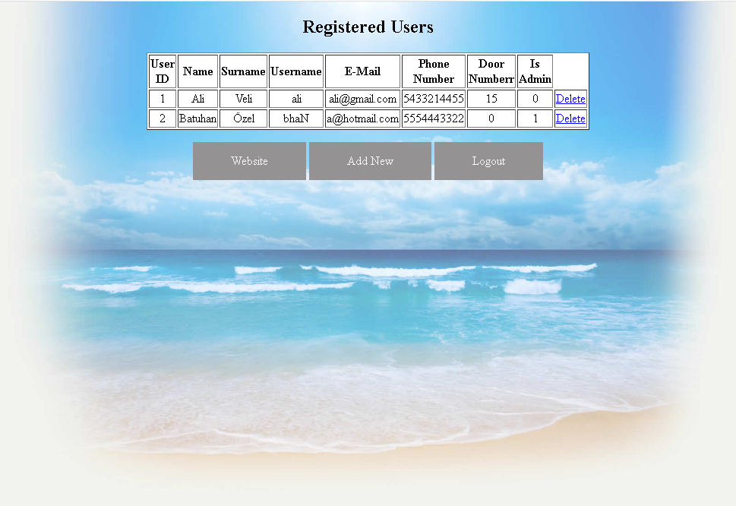

This is Logout Tab



ADD EDIT and DELETE Contents of Tables

I will do just Occupants Table but it is same for all tables

Add new Occupant

This screen occurs when we click edit in occupants tab



To add new Occupant we should click Add New Button.

When we click add new button, this screen occurs

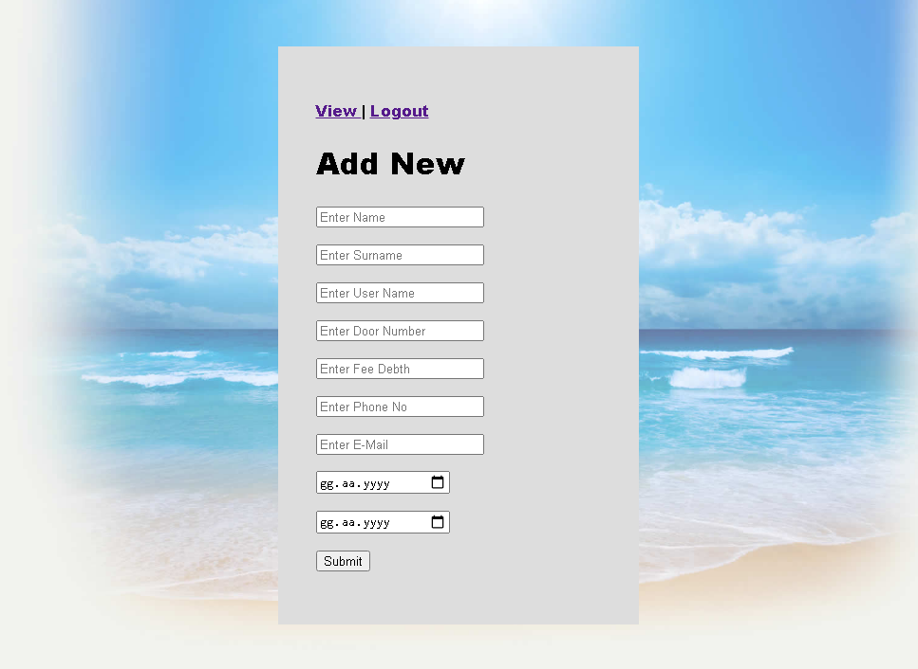

When we click submit wtihout doing anything, we get this warning for all rows except last row which is Move Out Date



We are adding our new occupant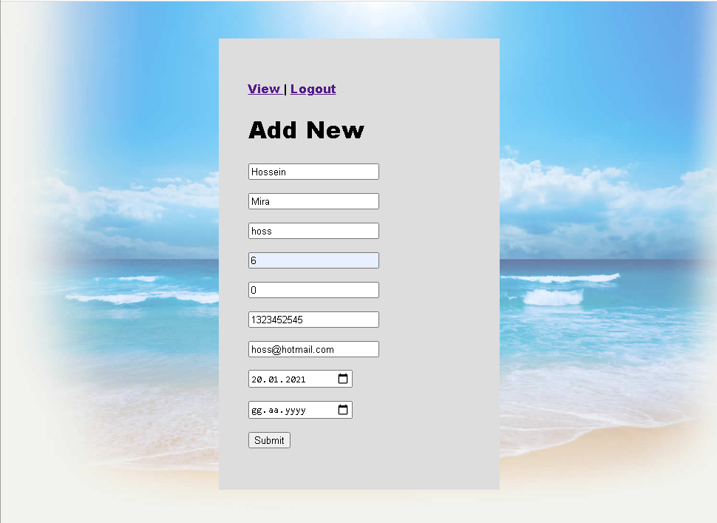

When we click submit this screen occurs

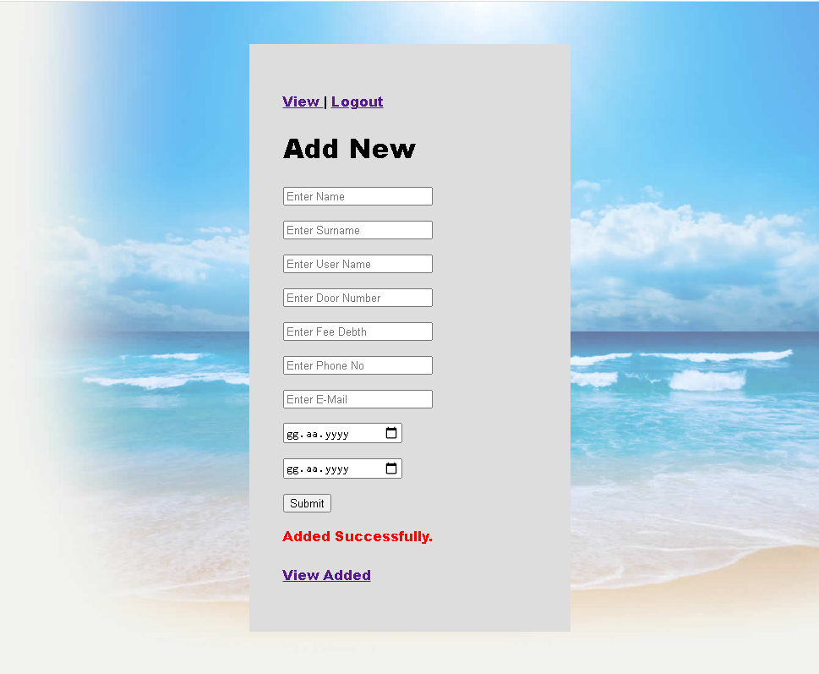

And our new user added to our table in website and database

Website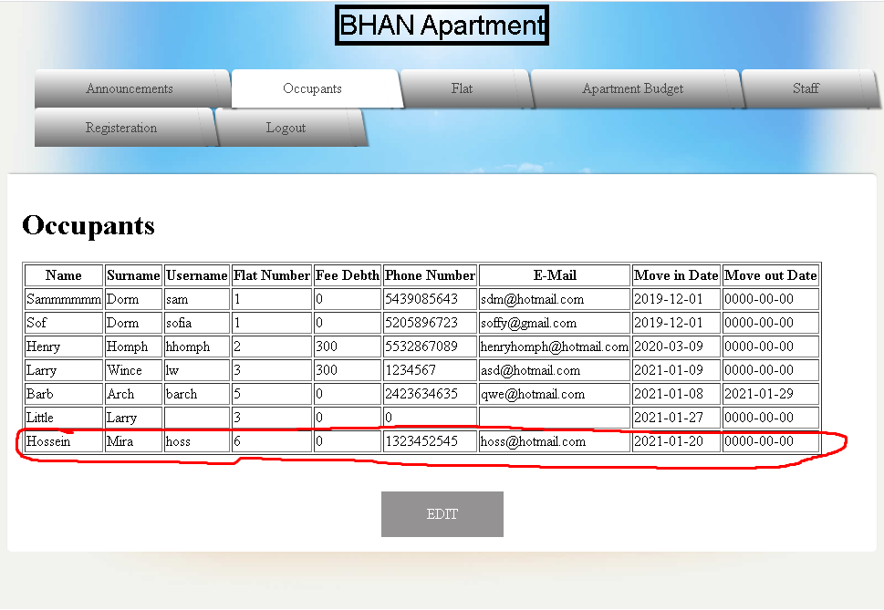

Database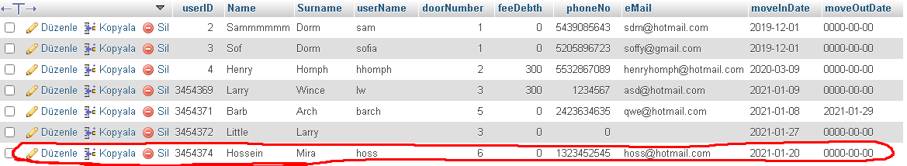

To delete a occupant click delete link

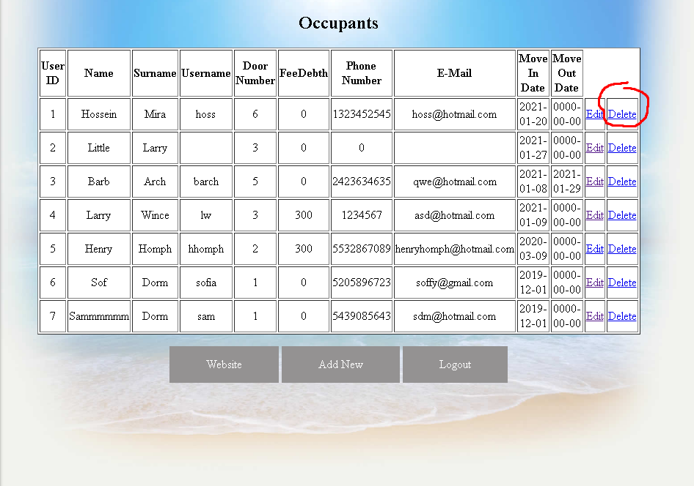

After clicking it, website says Deleted successfully and refreshes and turns back this table above without our deleted data

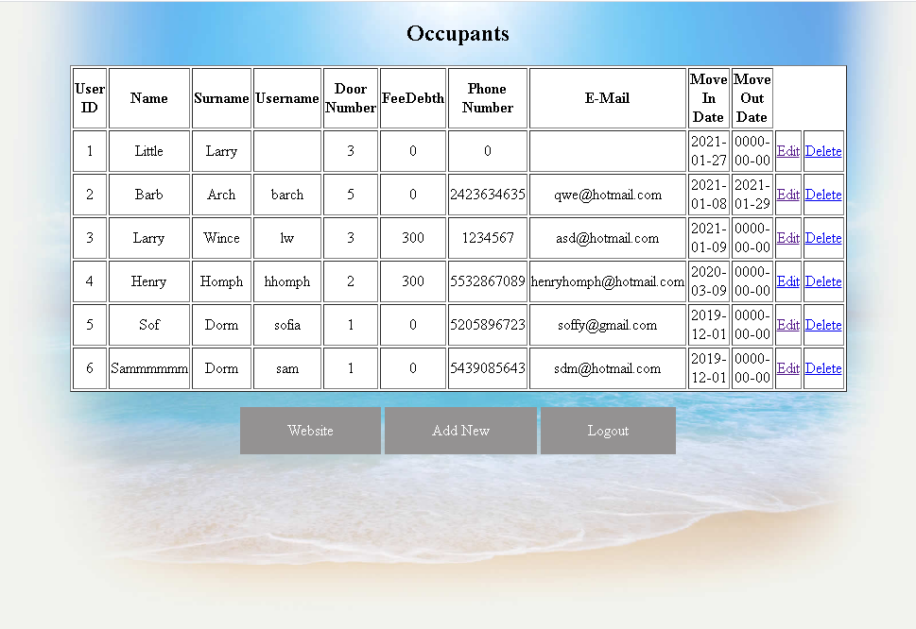

Hossein doesn’t appear anymore in that table and database

Editing An occupant

Lets edit Little Larry’s all information. When we click Edit link near Larry,



This screen occurs

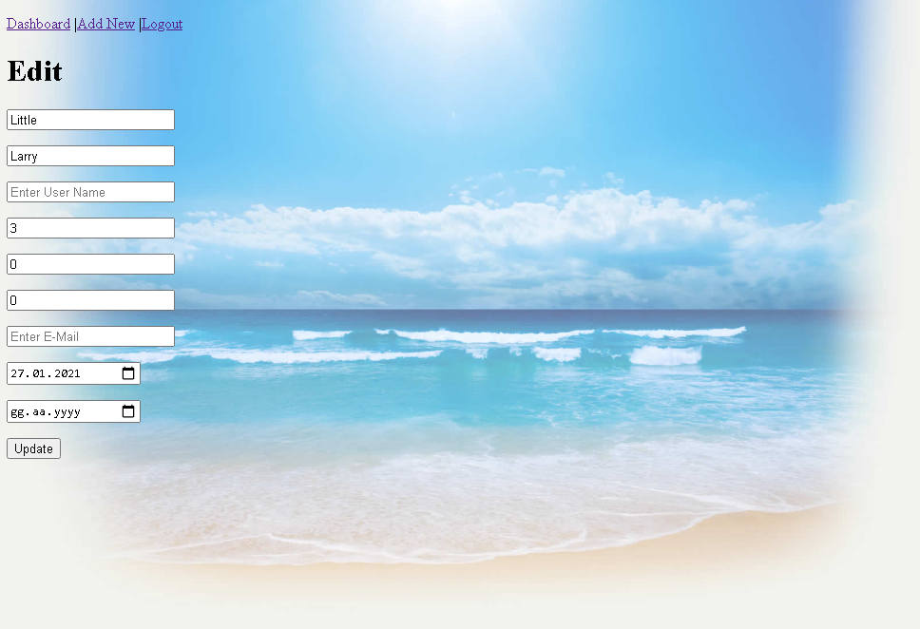

Lets say Little Larry Becomes Big Larry and moves from our apartment at 31st of January. So I update information like that

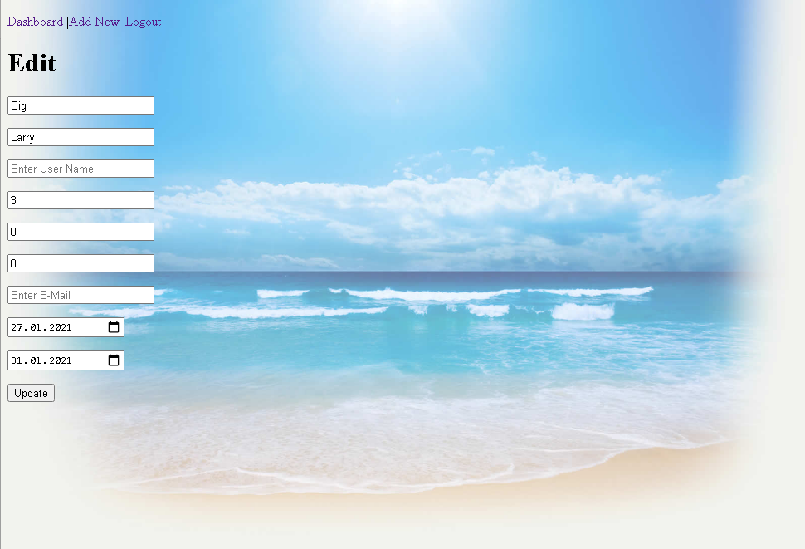

When I click update, this screen occurs



Our Little Larry has promoted to Big Larry

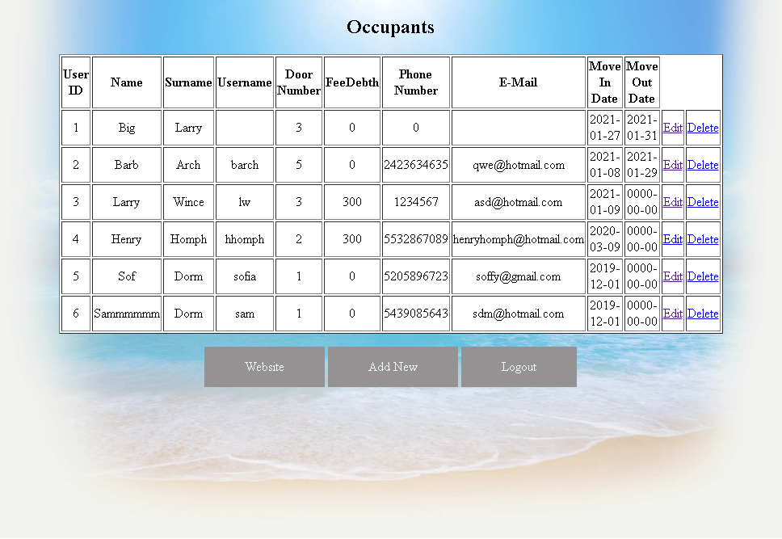

I have uploaded my codes in zip file, my github and this report to MS Teams Uploaded Github Directly without zip file

BATUHAN ÖZEL

20170808013